Nakayoshi Gakko
Arts and Crafts Committee

Class: Taiko - Tsuru

Project: Hachimaki

Material: Red and Purple Symphony Fabric, Thread, Yarn

Qty. Needed: 24

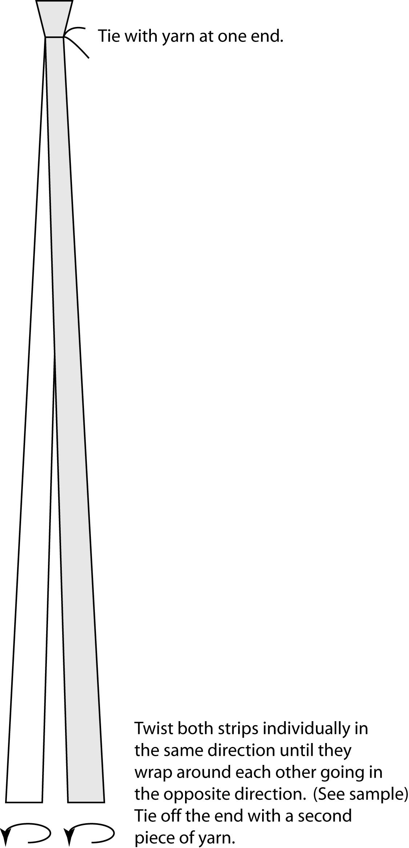
Instructions: Cut red and purple fabric into 6” x 47” strips
(12 red and 12 purple).

Cut 6" lengths of yarn.

Sew a simple 1/4” seam to finish raw edges of strips
(no need to roll hem).
Use one piece of yarn to
tie one red strip and one purple strip together at one end. Twist the two strips individually in one direction until they wrap around each other going in the opposite direction. Tie off the other end with a second piece of yarn. (See samples)

Due Date: Bring completed project with you to the Maintenance I Day prior to the start of session. Please return sample, unused materials and supplies.

Thank you in advance for your help. ☺

